Geometry: Unit 5, Lesson 4
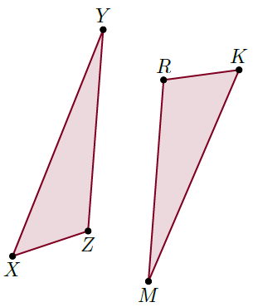
- $∆XYZ$ and $∆KMR$ are shown where $∆XYZ≅∆KMR$. What angle is congruent to $∠YZX$?

$$∠MRK$$

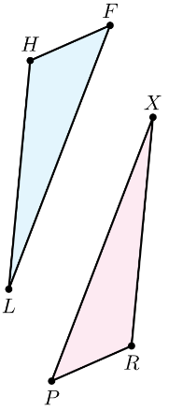

- $∆LHF$ and $∆XRP$ are shown where $LHF≅∆XRP$. What line segment is congruent to $\overline{HF}$?

$$\overline{RP}$$

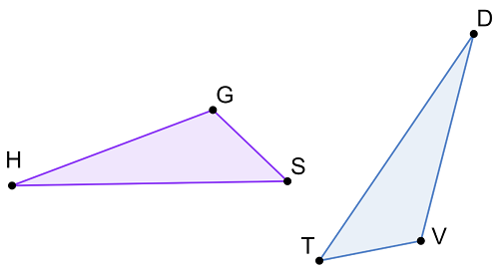
- Two congruent triangles are shown where $∆GHS≅∆VDT$. Complete the following statement:
$$∠SHG≅__________$$

$$∠TDV$$

